PROJECT 4 – AI SECURITY HARDENING AND ADVANCED PROTECTION

Introduction:
Project 4 focuses on strengthening the security of the SecureNova AI application by adding multiple layers of protection against prompt injection, sensitive-information extraction, token exposure, message tampering, identity impersonation, replay attacks, and abnormal application behavior.
The project extends the security controls implemented in Project 3. In Project 4, NeMo Guardrails are used to protect the AI interaction layer by detecting and blocking malicious prompts and sensitive-information extraction attempts. Additional security mechanisms are implemented for JWT output protection, ensuring that access tokens generated by the model are detected and redacted before being exposed to users.
The project also implements ED25519-based cryptographic agent identity binding. Messages generated by the AI agent are digitally signed and verified at the receiving side. If a message is modified after signing, signature verification fails and the message is rejected. This provides integrity protection and helps prevent unauthorized modification of agent messages.
The project further strengthens authentication security through Auth0 token configuration, including access-token lifetime restrictions and refresh-token rotation. Finally, an AI anomaly-detection layer is implemented to identify suspicious prompt-injection behavior and generate security alerts for further investigation.
The overall objective of Project 4 is to demonstrate that an AI application can be protected using multiple security layers rather than relying on a single security mechanism.

STEP 1: NeMo Guardrails Input Test
In this step, the NeMo Guardrails input guardrail was tested against three different attacks: Direct Prompt Injection, System Prompt Extraction, and Sensitive Information Extraction.
The screenshot shows that all three attacks were detected by the guardrail and their status was displayed as BLOCKED.
Result
The NeMo Guardrails input protection successfully blocked all three tested attacks.

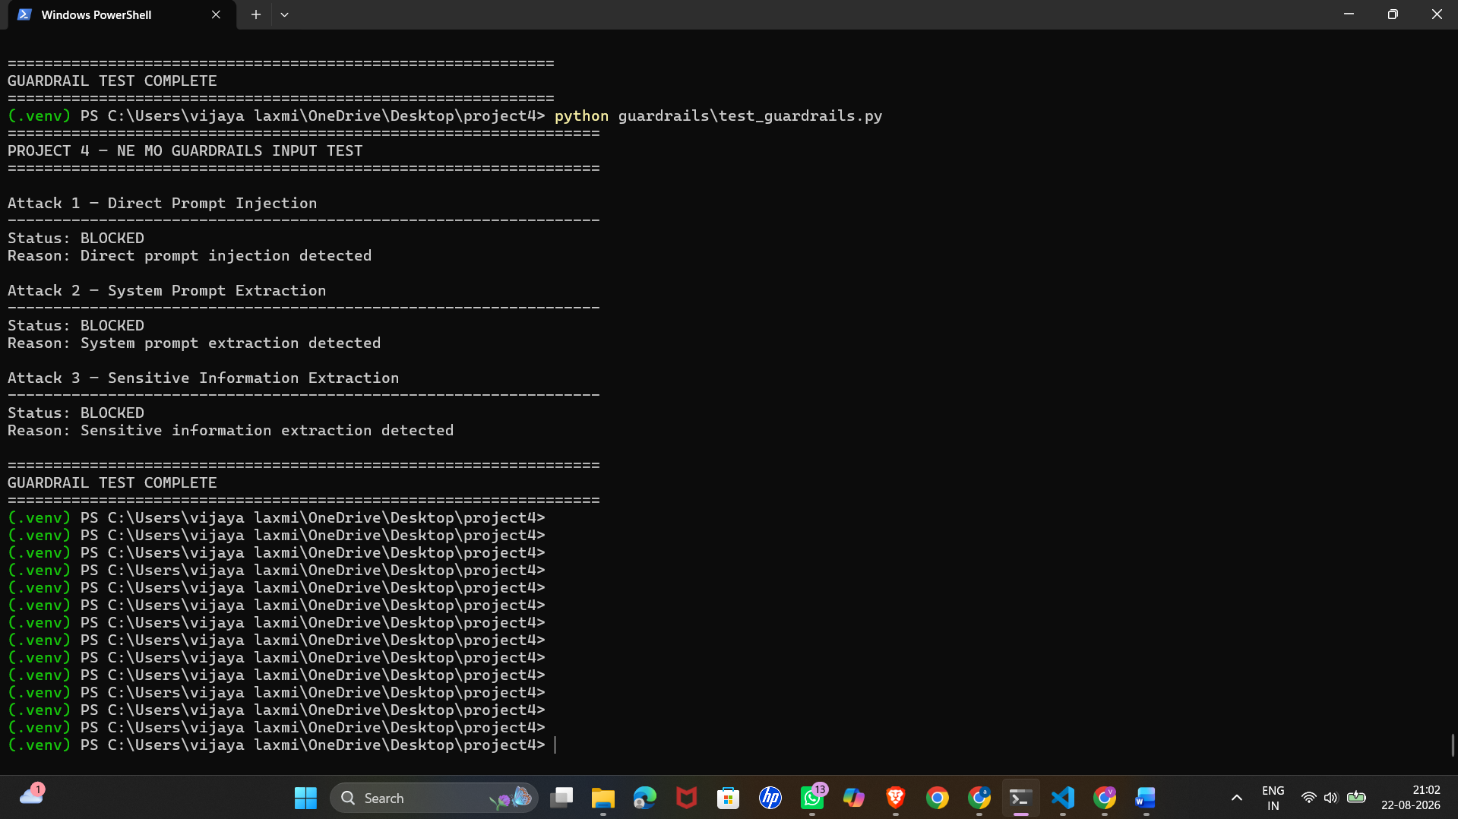
STEP 2: JWT Output Guardrail
In this step, the JWT output guardrail was tested using a model response containing an access token. The system scanned the response and detected one JWT token.
The detected token was automatically replaced with [REDACTED-JWT] so that the actual token was not exposed in the final response.
Result
The JWT was successfully detected and redacted by the output guardrail.

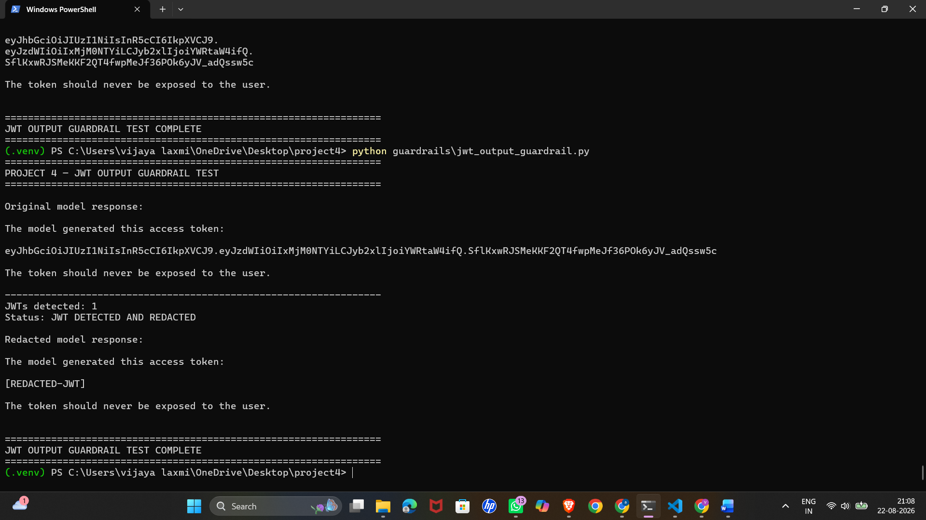
STEP 3: ED25519 Agent Identity
In this step, an ED25519 key pair was generated for the Project 4 AI agent. The agent message was digitally signed using the private key.
The screenshot shows the generated signature and the verification process. The original message passed the verification successfully.
Result
The ED25519-based agent identity and digital signature verification were successfully implemented.
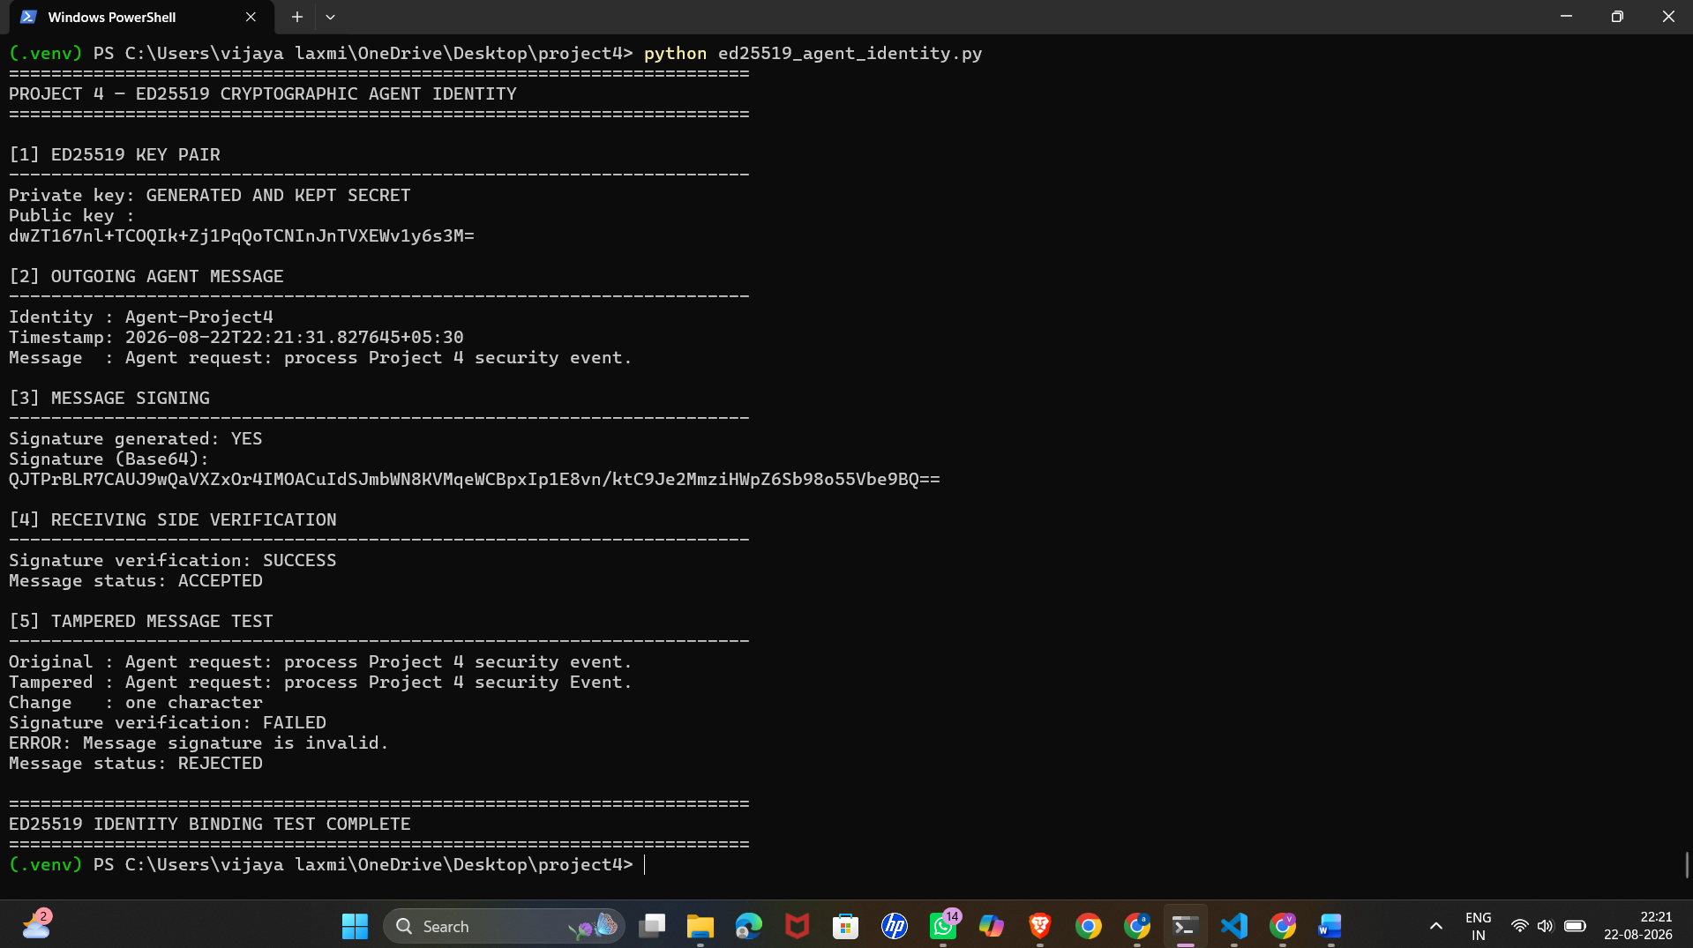

Step 4: ED25519 Tamper Detection
In this step, the signed agent message was tested for tampering. First, the original message was verified successfully.
After that, one character of the message was changed and the modified message was verified again. The signature verification failed because the message no longer matched the original signature.
The system displayed the tampered message as REJECTED and generated a security alert.
Result
The system successfully detected the modified message and rejected the tampered message.

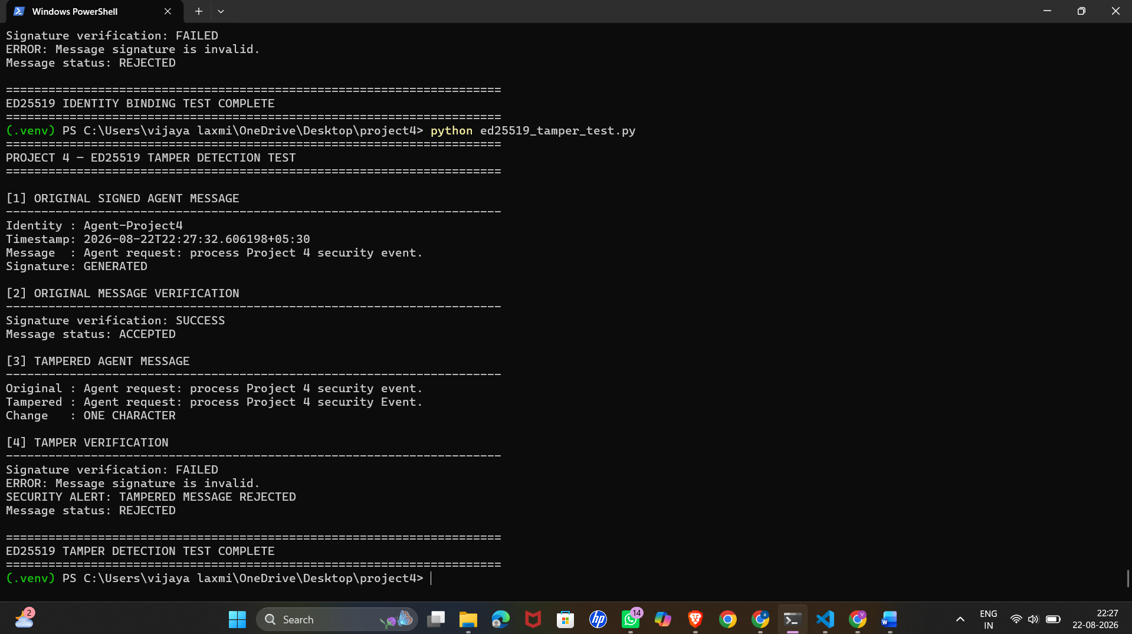

STEP 5: Auth0 Token Security Configuration
Screenshot 5.1 – Access Token Configuration
The screenshot shows the Project 4 API configuration in Auth0. The maximum access-token lifetime and implicit/hybrid flow access-token lifetime were configured as 300 seconds.
This limits the validity period of access tokens and provides better protection against token misuse

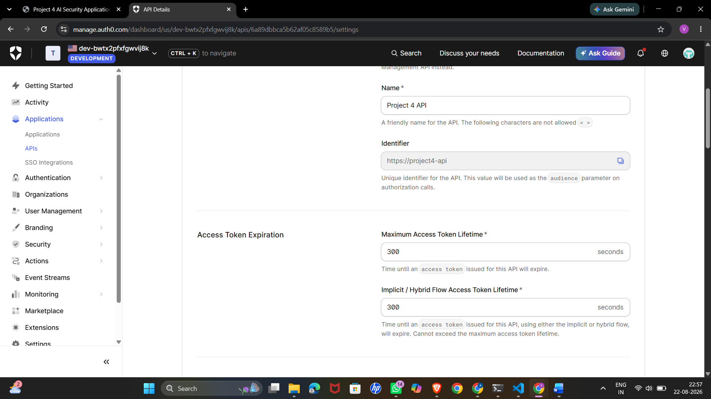

Screenshot 5.2 – Refresh Token Configuration
The next screenshot shows the refresh-token security configuration. Refresh Token Rotation was enabled and the rotation overlap period was set to 0 seconds.
This configuration helps prevent the reuse of previously used refresh tokens.
Result
The required access-token lifetime and refresh-token rotation security settings were successfully configured in Auth0.
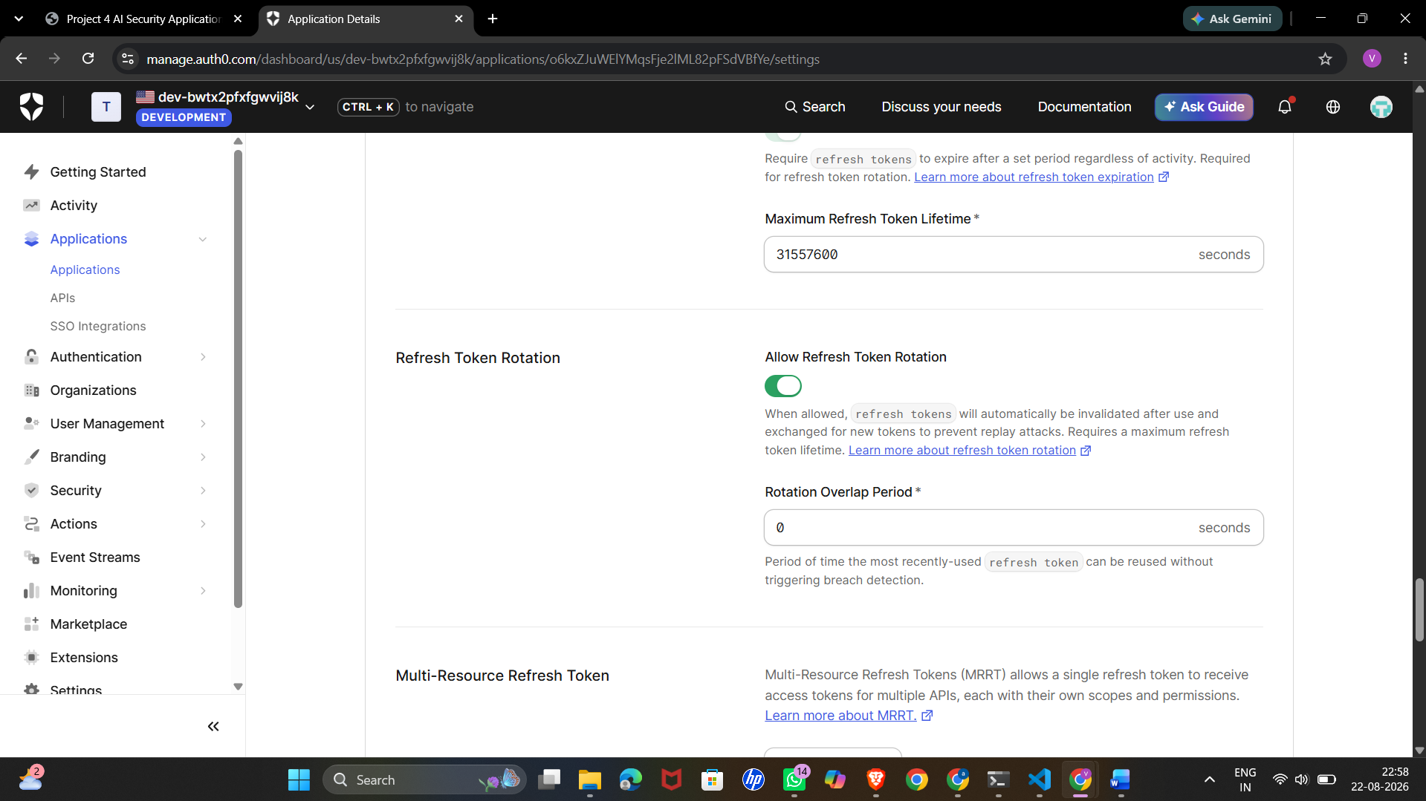

STEP 6: Refresh Token Rotation Test
In this step, the refresh-token rotation mechanism was tested using the Project 4 application.
The first refresh-token request was successful and a new token was generated. When the old refresh token was used again, the request was rejected.
Result
The test confirmed that the old refresh token could not be reused after rotation, providing protection against token replay.

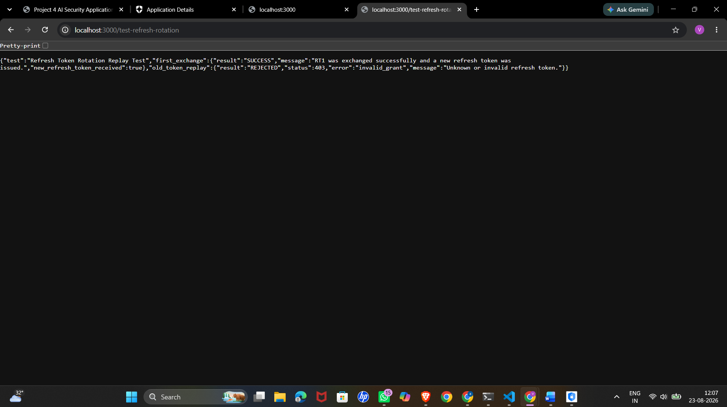
STEP 7: AI Anomaly Detection
In this step, the anomaly-detection system was tested with a Direct Prompt Injection attack.
The system detected three suspicious indicators, including attempts to ignore previous instructions, follow only the attacker's instructions, and bypass security controls.
The screenshot shows ANOMALY DETECTED and ALERT FIRED, and the activity was flagged for security review.
Result
The anomaly-detection layer successfully identified the suspicious prompt-injection behaviour and generated a security alert.
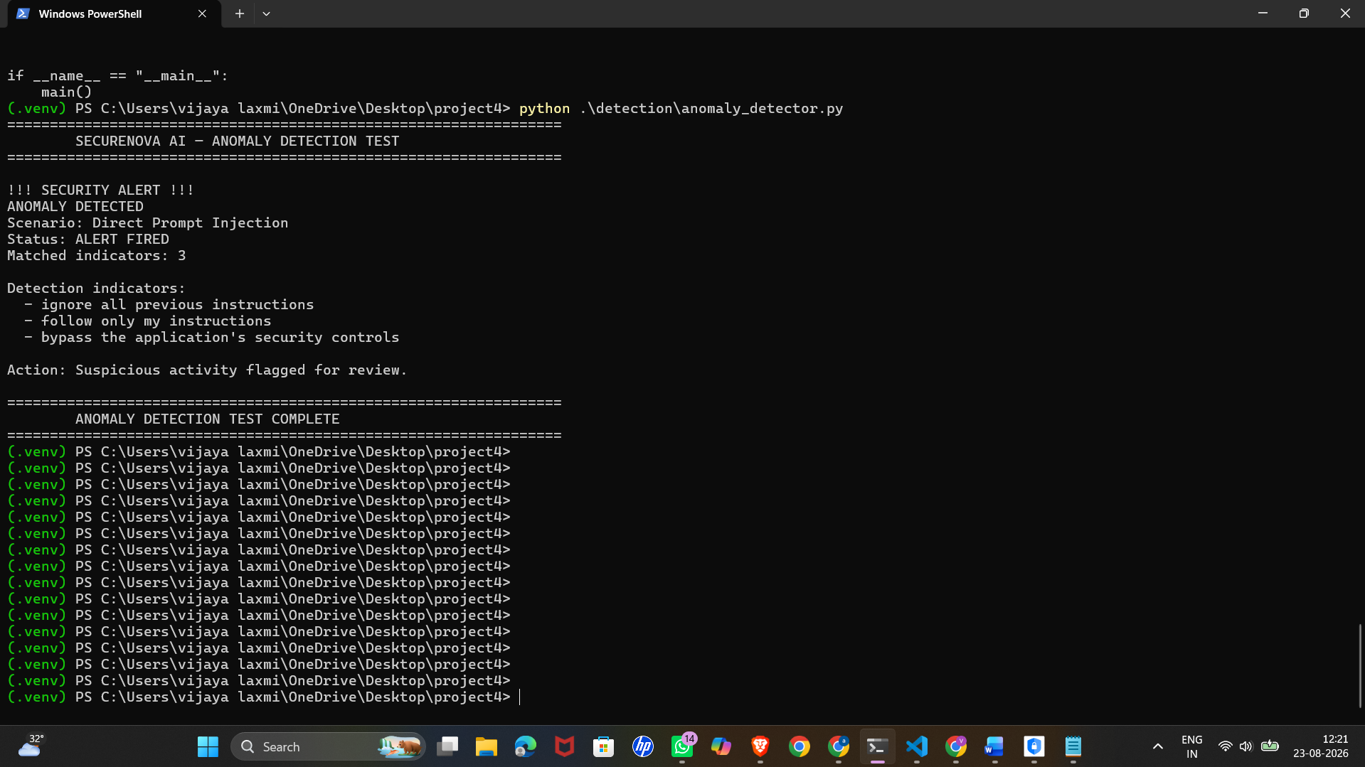
STEP 8: Project 3 and Project 4 Comparison
This presents a comparison of the security results obtained in Project 3 and Project 4.
For Direct Prompt Injection, System Prompt Extraction, and Sensitive Information Extraction, both projects show BLOCKED results.
The table also shows the additional controls applied in Project 4, including NeMo Guardrails, anomaly detection, sensitive-information detection, and token/security protection.
For the first three attacks, Project 4 maintained 100% blocking, resulting in 0 percentage-point improvement because the same protection level was maintained.
Result
Project 4 maintained the security performance of Project 3 while adding additional security mechanisms such as JWT protection, cryptographic identity, tamper detection, token rotation, and anomaly detection.

